Facial Toner
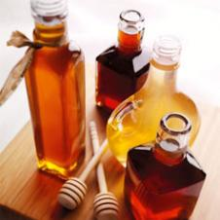

Ingredients

- 1 Tablespoon - honey
- 1 - apple, peeled and cored

Directions
In blender, puree honey with a peeled, cored apple. Smooth over face; leave on 15 minutes. Rinse with cool water.

