Hair Shine
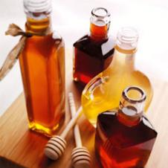

Ingredients

- 1 teaspoon - honey
- 4 cups - warm water
- Lemon (for blondes)

Directions
Stir honey into warm water. Blondes may wish to add a squeeze of lemon. After shampooing pour mixture through hair. Do not rinse out. Dry as normal.

