Honey Cleansing Scrub
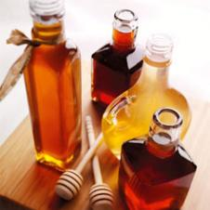

Ingredients

- 1 Tablespoon - honey
- 2 Tablespoons - finely ground almonds
- 1/2 teaspoon - lemon juice

Directions
Mix all ingredients. Rub gently onto face. Rinse off with warm water.

